Figures and Table for Appendix

ENERGY ISSUES IN THE CALIFORNIA-BAJA CALIFORNIA

Figure 1

Mexican Natural Gas Demand by Sector
2000 –2009
(billion cubic feet per day)
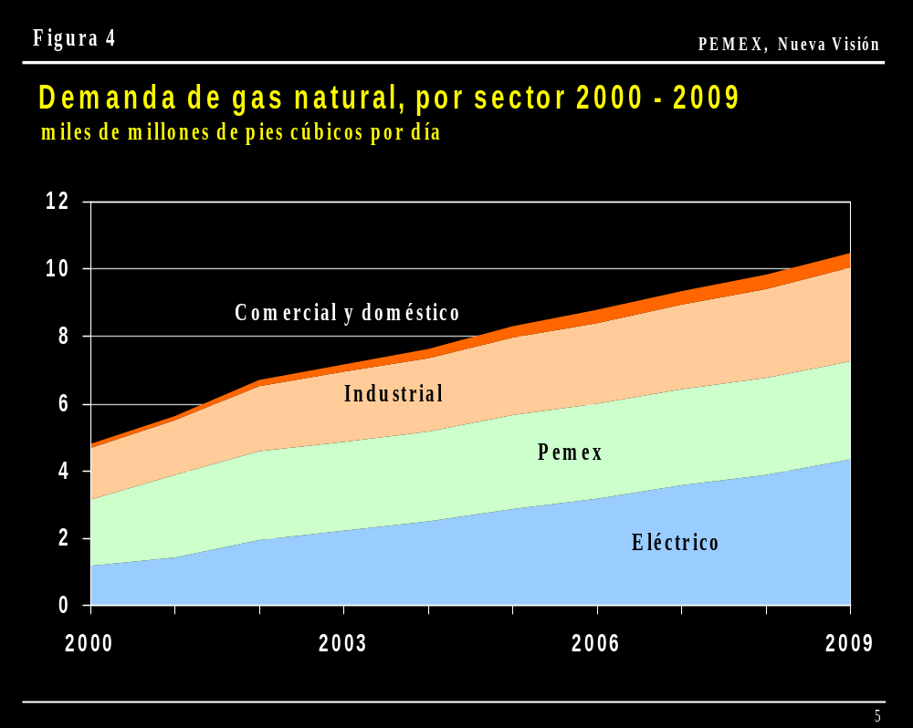
Source: PEMEX

Figure 2

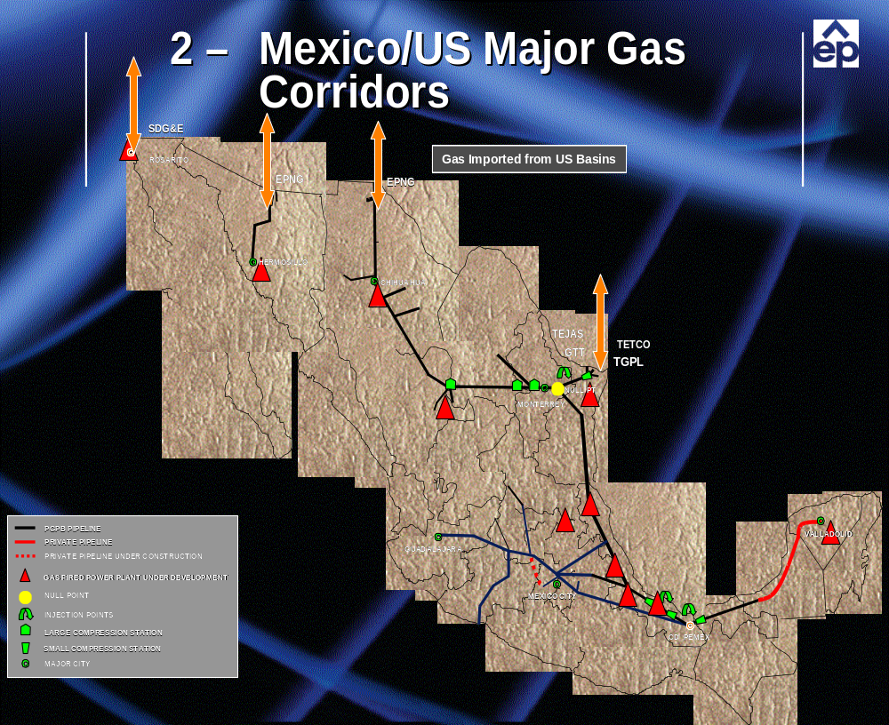

Source: El Paso Natural Gas Company

Figure 3

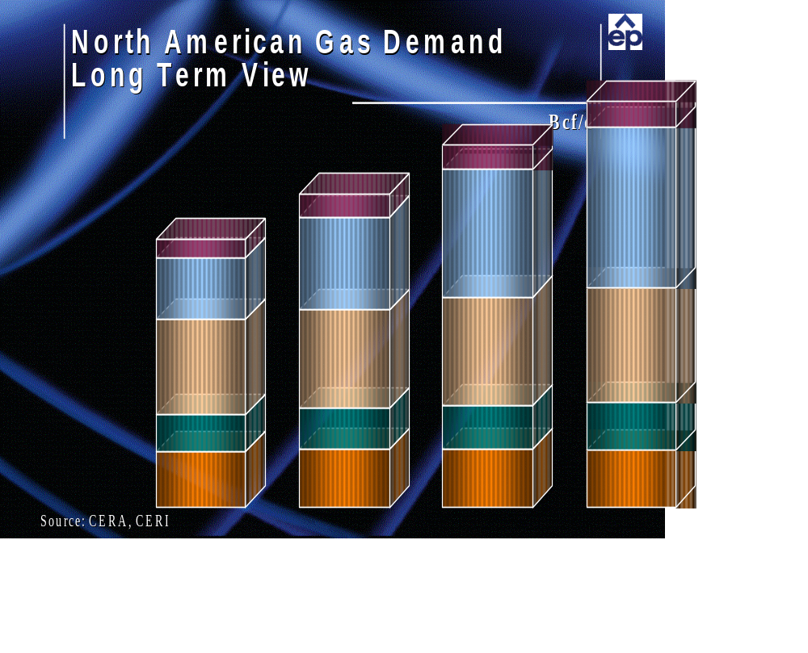

Source: Cambridge Energy Research Associates and Canadian Energy Research Institute

Figure 4

MAIN POWER TRANSMISSION LINES IN MEXICO AS OF 1999

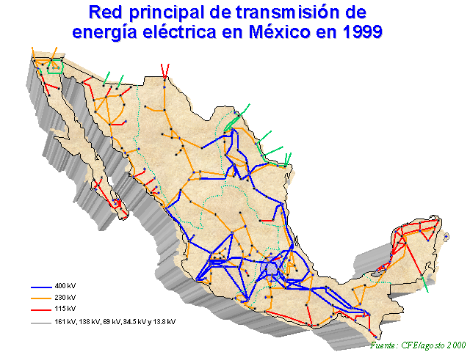

Source: CFE, August 2000
Figure 5

CORSS BORDER POWER TRANSMISSION LINES IN 1999

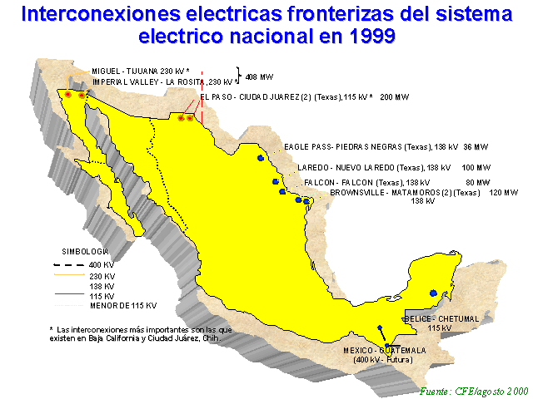

Source: CFE, August 2000
Figure 6

HISTORICAL AND PROJECTED MEXICAN NATURAL GAS DEMAND

1991-2008

(million cubic feet per day)

(TCPA = average annual growth rate)

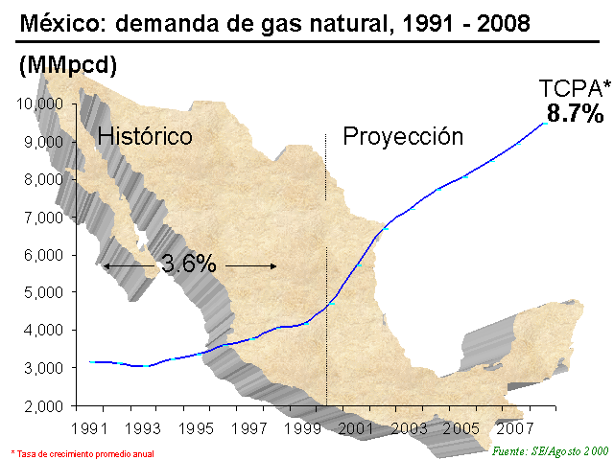

Source: Ministry of Energy, Mexico, August 2000
Figure 7

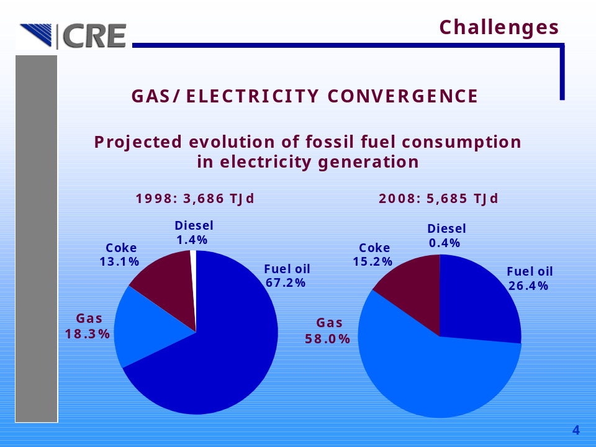

Source: Mexican Energy Regulatory Commission (CRE)
Figure 8

CONSUMPTION OF NATURAL GAS FOR THE GENERATION OF ELECTRICITY IN MEXICO

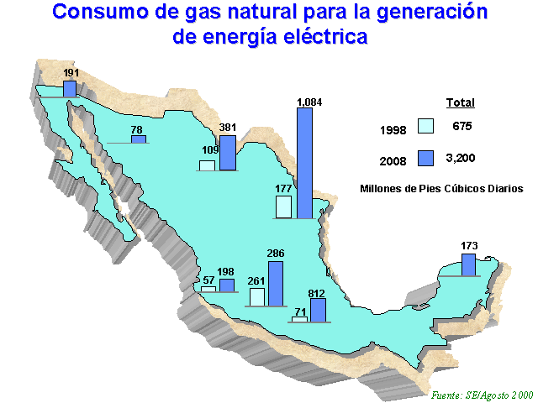

Source: Mexican Ministry of Energy (SE), August 2000
Figure 9

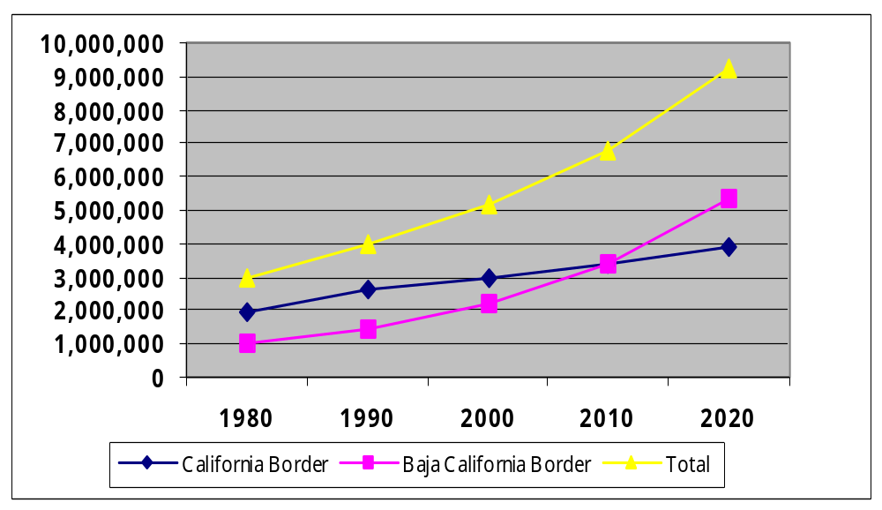CALIFORNIA-BAJA CALIFORNIA BORDER POPULATION, 1980–2020

Source: The U.S.-Mexican Border Environment: A Road Map to a Sustainable 2020. San Diego State University Press. Paul Ganster, editor, 2000

TABLE 1

BAJA CALIFORNIA GENERATING FACILITIES

Municipality | Site | Fuel | Capacity in MW
Tijuana | Tijuana | Diesel | 55
Rosarito | Rosarito | Fuel oil & Natural gas | 1330
Mexicali | Cerro Prieto I  Cerro Prieto II  Cerro Prieto III  Cerro Prieto IV | Geothermal  Geothermal  Geothermal  Geothermal | 180  220  220  100
Ensenada | Cipres | Diesel | 55
Total |  |  | 2160

Source: CFE, 2001

Table 2

ESTIMATED RENEWABLE AND ALTERNATIVE ENERGY RESOURCES FOR BAJA CALIFORNIA

ENERGY SOURCE | POTENTIAL
Geothermal | 1000 MW proven reserves (Mexicali)
Solar | 3.3-6.9 kWh/m²
Wind | 100-250 W/m²
Biomass:  Agricultural waste | 3600m³ NGE/day (Mexicali)
Solid urban waste | 25-30 MWe + heat
Seaweed | ~75, 000 BOE/year
Fuel wood | Negligible
Mycrohydroelectric | ~80 MWe (Mexicali)  ~20 MWe (Tecate)
Tidal Power | ~1200 MWe (Gulf of Cortez)
Source: Huacuz, 1995

